SPACEPORT MANAGEMENT SYSTEM


Abdulrahman Ahmed
241004780
Mohamed Mahmoud
241005267
Ahmed Mohamed Ghazy
241016096
Seif Mohamed Bakry
241004799
Mohamed Reda Morsy
241006699
Hazem Sherif
241005797

Project Overview
SDG 9 INNOVATION AND INFRASTRUCTRE

The Spaceport Management System is an object-oriented Java application designed to
manage a commercial spaceport facility. The system handles rocket operations,
trip scheduling, passenger bookings, maintenance operations, and personnel
management through a comprehensive class hierarchy and database integration.

Key Features:
Trip scheduling and ticket booking system
Employee management (Administrators, Pilots, Technicians)
Launch pad management and assignment
Navigation system integration

2.1 INHERITANCE
Method Overriding: toString(), equals() methods overridden in multiple classes
Runtime Polymorphism: Method calls resolved at runtime based on actual object type

2.3 ENCAPSULATION
Controlled access to internal state through access modifiers
Abstract Person class defines common interface without implementation
Hides implementation details while exposing essential functionality

2.5 COMPOSITION
Spaceport contains: Location, ArrayList<NavigationSystem>
Strong ownership relationships where parts cannot exist independently

2.6 AGGREGATION
MaintenanceTeam aggregates: List<Technician>
Pilot associated with: Rocket, NavigationSystem, LaunchPad, Trip
Administrator associated with: Spaceport, Rocket, LaunchPad

2.8 DESIGN PATTERNS
Dependency Injection: tripDAO receives RocketDAO and LaunchPadDAO via constructor
RocketStatus: READY, IN_MAINTENANCE, AVAILABLE, IN_FLIGHT
BookingStatus: CONFIRMED, CANCELED, AVAILABLE, TAKEN, PENDING
EngineStatus: OPERATIONAL, IN_MAINTENANCE, POWERED_OFF
4.1 PASSENGER WORKFLOW

Step 1: Login/Registration
• Enter role: "P" or "Passenger"
• Enter name and email
• System checks for existing account by email
• If new: Enter age to create account
• If existing: Welcome message displayed

Step 2: Browse Available Trips
• System displays all scheduled trips with:
- Trip number
- Destination location
- Departure time

Step 3: Select Trip
• Choose trip by number from displayed list

Step 4: Select Class Tier
• Options: 1. ECONOMY, 2. BUSINESS, 3. FIRST
• Enter choice (1-3)

Step 5: Booking Confirmation
• System assigns available ticket
• Displays booking confirmation with:
- Trip number
- Class tier
- Seat number
- Price

4.2 ADMINISTRATOR WORKFLOW

Menu Options:
1. Schedule New Trip
• Enter trip number (e.g., T-01)
• Enter destination location
• Enter launch date
• Enter launch pad ID
• Enter required crew count
• System creates trip and generates tickets (2 Economy, 2 Business, 2 First)

2. Manage Rocket Status (Fuel/Inspect)
• Sub-option: "Fill fuel"
- Enter fuel amount
- System refuels rocket
• Sub-option: Change status
- Enter status: "ready", "maintenance", or "midair"
- System updates rocket status

3. View Trip Manifest/Roster
• Enter trip ID
• System displays all passengers booked on trip with:
- Passenger name and ID
- Class tier
- Seat number

4. Execute Launch Sequence
• System checks if rocket status is READY
• If ready: Changes status to IN_FLIGHT
• If not ready: Displays error message

5. Register a New Rocket
• Enter registration ID
• System creates new rocket with default status AVAILABLE

0. Log Out
• Exits administrator menu

4.3 PILOT WORKFLOW

Menu Options:
1. Start Rocket Engine
• Pilot starts assigned rocket's engine
• System checks for assigned rocket and engine
• Updates engine status to OPERATIONAL

2. Fuel Consumption Estimation
• Enter flight time in hours
• System calculates and displays fuel consumption based on current throttle

3. Estimate Distance
• System displays available destinations
• Enter destination name
• System calculates and displays distance in kilometers

4. Adjust Throttle
• Enter throttle percentage (30-100)
• System updates throttle setting
• Displays current thrust and carbon footprint

5. Execute Launch
• System changes rocket status to IN_FLIGHT

0. Exit
• Exits pilot menu

4.4 TECHNICIAN WORKFLOW

Menu Options:
1. View Hangar Rockets
• System displays all rockets with status IN_MAINTENANCE
• Shows: Registration ID, Engine Type, Status, Database ID

2. Assign Service to Next Rocket
• System displays all available rockets
• Enter rocket ID to assign for maintenance
• System updates rocket status to IN_MAINTENANCE

3. View Inventory Parts
• System displays central parts inventory
• Shows: Part ID, Part Name, Quantity

4. Add Part to Inventory
• Enter part name
• Enter quantity to add
• System adds to existing stock or creates new part

5. Update Part Quantity
• Enter part name
• Enter new total quantity
• System updates inventory quantity

6. Hire New Technician
• Enter technician name
• Enter employee ID
• Enter department
• Enter salary
• Enter age
• System creates new technician record

0. Log Out
• Exits technician menu

Our fully comprehensive UML Diagram
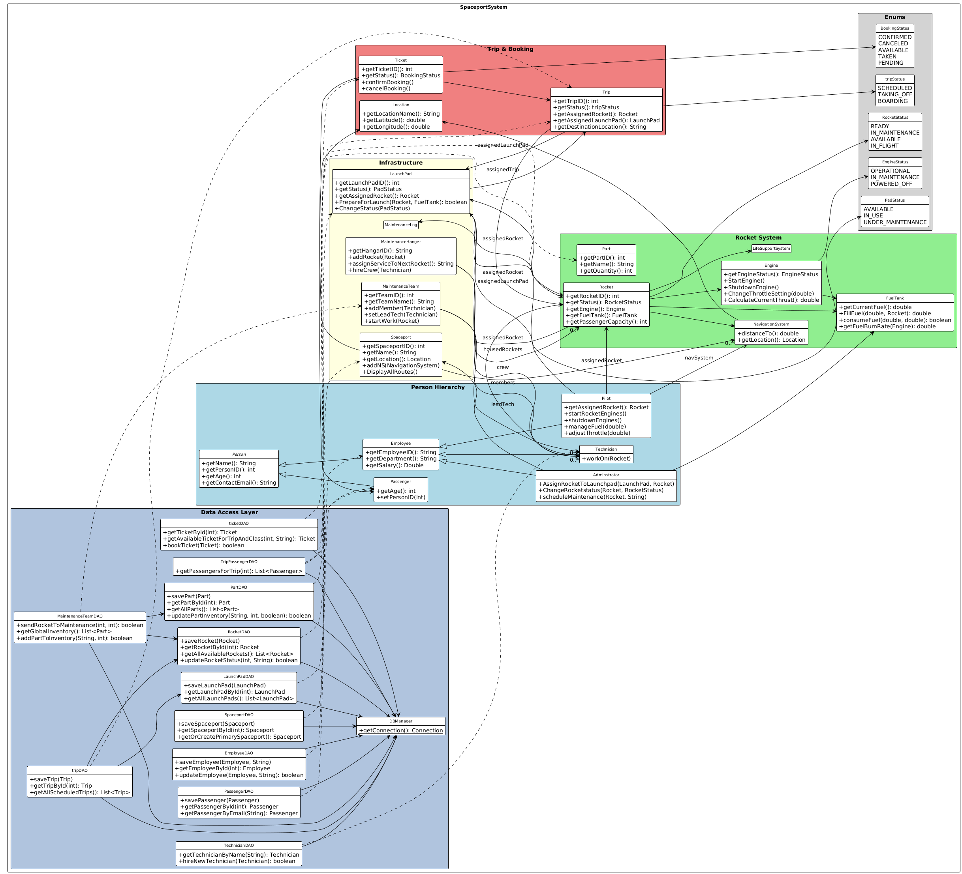

The complete Source code should be provided in a separate file.

